**ToyCraft Tales** **: Tableau's Vision into Toy Manufacturer Data**

## Project Description:

Employ Tableau to delve into Toy Manufacturers' data, uncovering market trends, production  
patterns, and consumer preferences. Craft interactive visualizations to guide strategic decisions and enhance market competitiveness’The Toy Manufacturers' Data Exploration and Visualization Project aims to leverage the power of Tableau to provide a comprehensive analysis of the toy manufacturing industry. By delving into the vast dataset encompassing various facets of the industry, the project seeks to uncover valuable insights related to market trends, production patterns, and consumer preferences.Utilize Tableau to dissect market trends within the toy manufacturing sector.

Explore historical sales data, identify emerging market demands, and highlight patterns that can inform strategic decisions. By visualizing market dynamics over time, the project aims to offer a deep understanding of the industry's evolution.Analyze consumer behavior and preferences by examining data related to popular toy categories, demographic trends, and purchasing patterns. Develop interactive visualizations that highlight consumer preferences, enabling manufacturers to align their product offerings with market demands. This insight is crucial for tailoring product development strategies to meet customer expectations.

### Scenario 1

Market Trend Analysis for Seasonal Products: The project could delve into historical sales data for different types of toys across various seasons and holidays. By visualizing the sales trends over the years, manufacturers can identify patterns in consumer preferences during specific times of the year. For instance, they might find that certain types of toys sell better during the holiday season, while others have higher demand during summer months. Armed with this insight, toy manufacturers can adjust their production schedules and marketing strategies accordingly to   
maximize sales and meet seasonal demands effectively

### Scenario 2

Consumer Preference Analysis Across Demographics: Using demographic data such as age, gender, and location, the project could analyze consumer preferences for different types of toys. Interactive visualizations can be created to show how preferences vary among different demographic groups. For example, it might reveal that teenagers in urban areas have a higher preference for electronic toys, while younger children in rural areas prefer traditional toys such as dolls and action figures. This information can help manufacturers tailor their product offerings and marketing campaigns to target specific demographic segments more effectively.

### Scenario 3

Product Performance Comparison Across Regions: By analyzing sales data across different regions or countries, the project could identify which toy categories perform better in certain geographic areas. For instance, it might find that educational toys are more popular in regions with a strong emphasis on education, while outdoor toys sell better in areas with favorable weather conditions. Visualizations could illustrate these regional differences in demand, allowing manufacturers to optimize their distribution channels and inventory management strategies to better serve each

## **Project WorkFlow:**

### Data collection & Extraction From Database

Activity 1.1:  Collect the dataset.

Activity 1.2: Storing data in DB

Activity 1.3: Connect DB with Tableau

### 2.  Data Preparation

Activity 2.1: No of Unique Visualizations

Activity 2.2 : Analysis of no of manufacturer by year

Activity 2.3 : Analysis on toy manufacturer in US state by index

Activity 2.4 : Analysis on toy manufacturer

Activity 2.5 : Top 10 states Toy Manufacturer in US state

3.Dashboard

Activity 3.1: Responsive And Design Of Dashboard.

4. Story :

Activity 4.1 : No Of Scenes Of Story

5.Performance Testing

Activity 5.1 : Amount Of Data Rendered To DB

Activity 5.2 : Utilization of Data Filters

Activity 5.3 : No Of Calculation Fields

Activity 5.4 : No Of visualizations / Graphs

6.Web Integration

Activity 6.1 : DashBoard And Story Embed With UI with Flask

7 .Project Demonstration & Documentation

**MILESTONE -1 :** **Data collection & Extraction From Database**

**Activity 1.1** : **Collect the dataset**

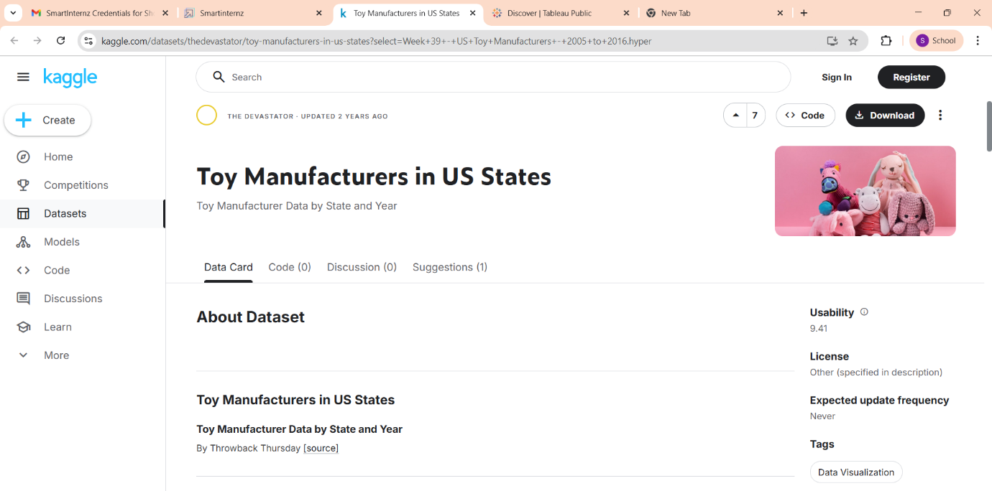

**Activity 1.2 : Storing Data in DB**

A database is an organized collection of data that allows efficient storage, access, and management. To store data in a database, you typically use a Database Management System (DBMS) such as MySQL, PostgreSQL, or SQLite**.**

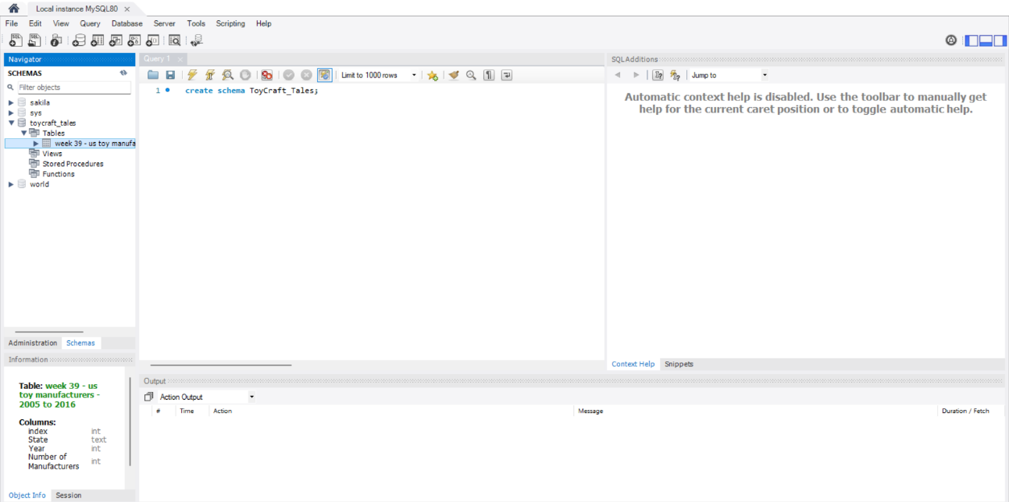

**Activity 1.3 : Connect DB with Tableau**

To analyze data in Tableau, you need to connect it to a data source. Tableau allows you to connect to a wide variety of databases like MySQL, PostgreSQL, SQL Server, Oracle.

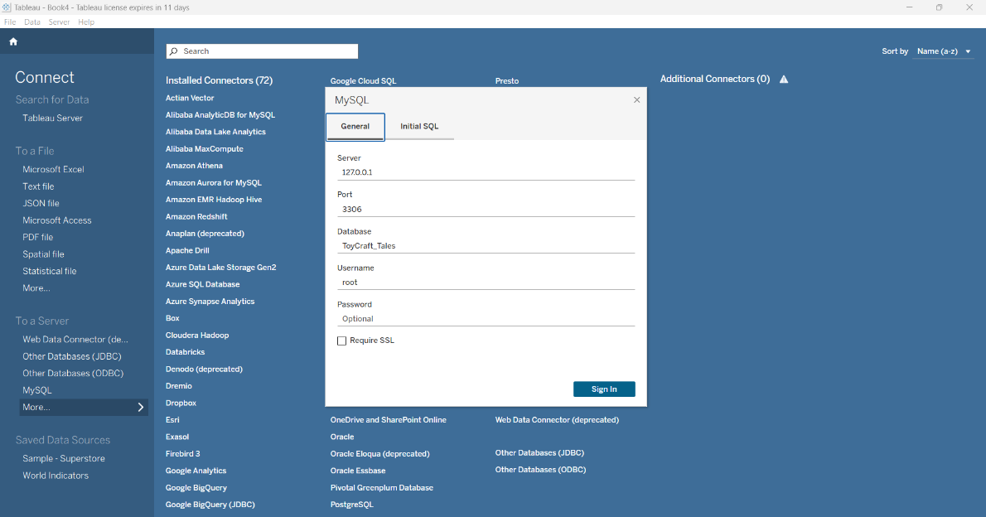

**MILESTONE -2 : Data Preparation**

**Activity 2.1 : No of Unique Visualizations**

The number of unique visualizations that can be created with a given dataset. Some common types of visualizations that can be used to analyze the performance and efficiency of ToyCraft Tales: Tableau's Vision into Toy Manufacturer Data include bar charts, line charts, heat maps, scatter plots, pie charts, Maps, etc. These visualizations can be used to compare performance, track changes over time, show distribution, and relationships between variables, breakdown of revenue and customer demographics, workload, resource allocation, and location of hotels

**Activity 2.2 : Analysis of no of manufacturer by year**

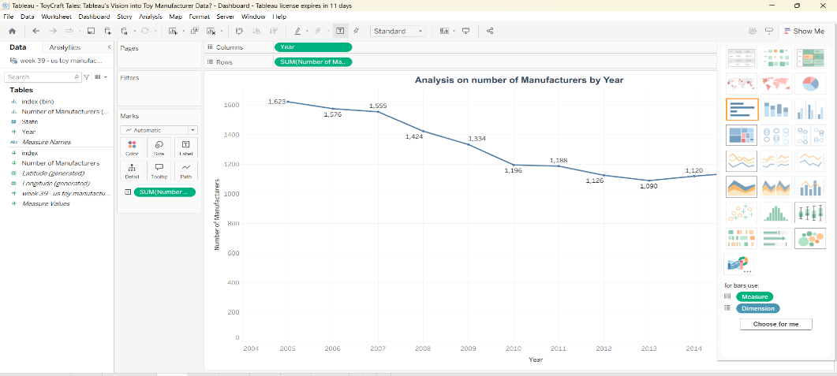

**Activity 2.3 : Analysis on toy manufacturer in US state by index**

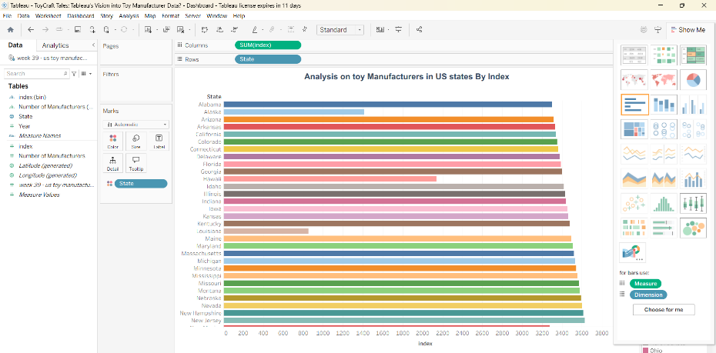

**Activity 2.4 : Analysis on toy manufacturers**

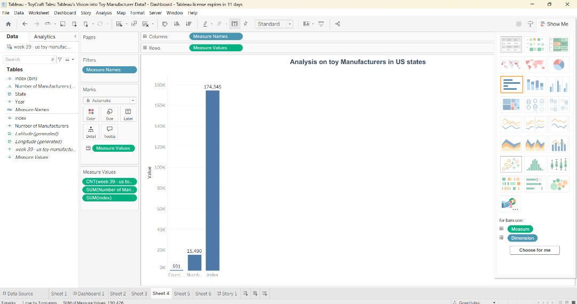

**Activity 2.5 : Top 10 states Toy Manufacturer in US state**

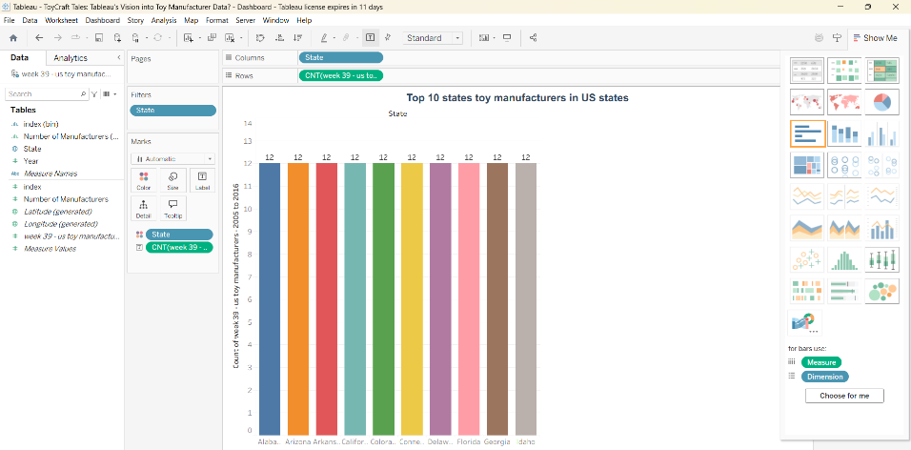

**MILESTONE 3 : Dashboard**

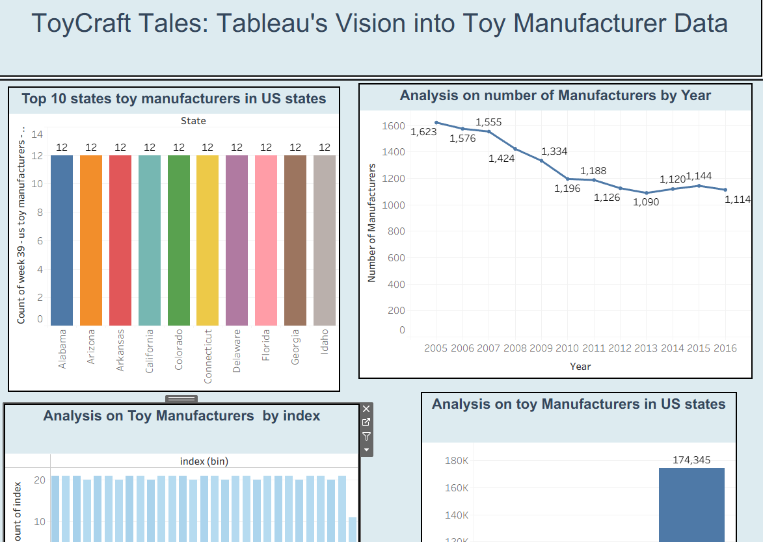

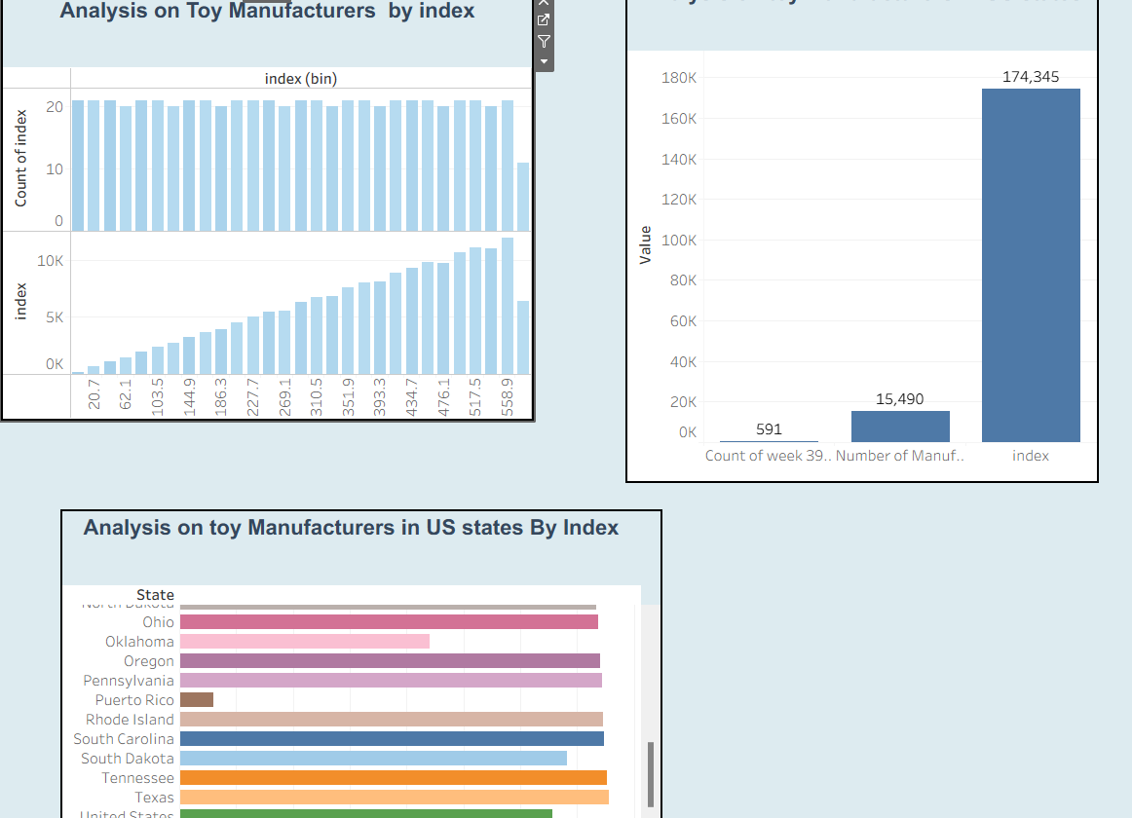

MILESTONE 4 : STORY

**Activity 4.1 No Of Scenes Of Story**

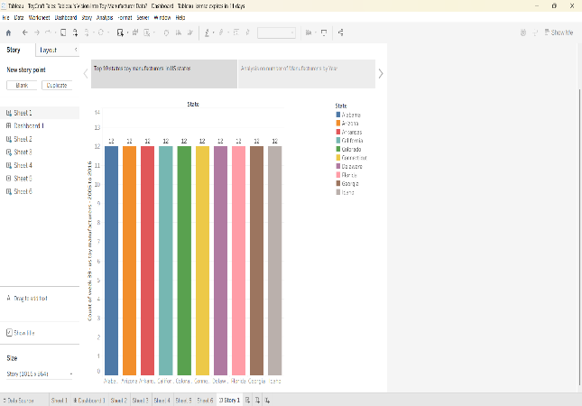 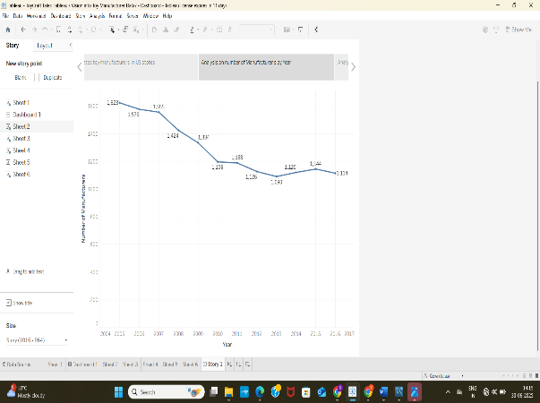

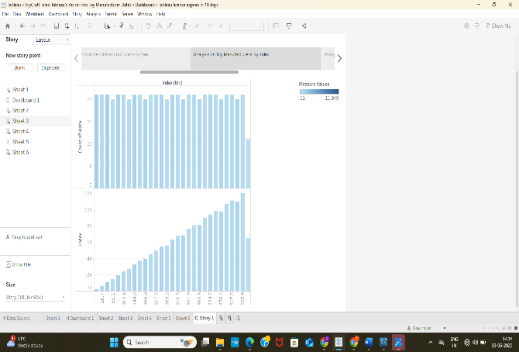 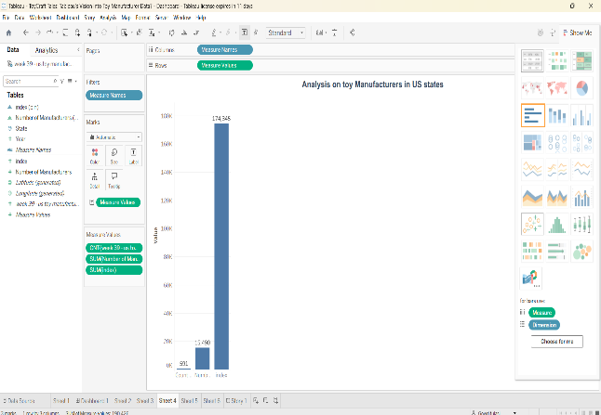

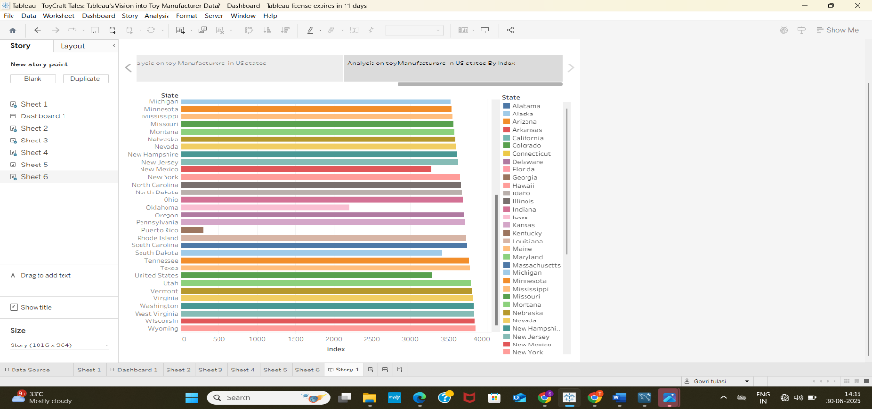

MILESTONE 5 : Performance Testing

**Activity 5.1 : Amount Of Data Rendered To DB**

The amount of data that is rendered to a database depends on the size of the dataset and the capacity of the database to store and retrieve data.

Open the MySQL Workbench, go to the database then click to expand the tables, select the table, and click on the (i) button to get the information related to the table such as column count, table rows etc.

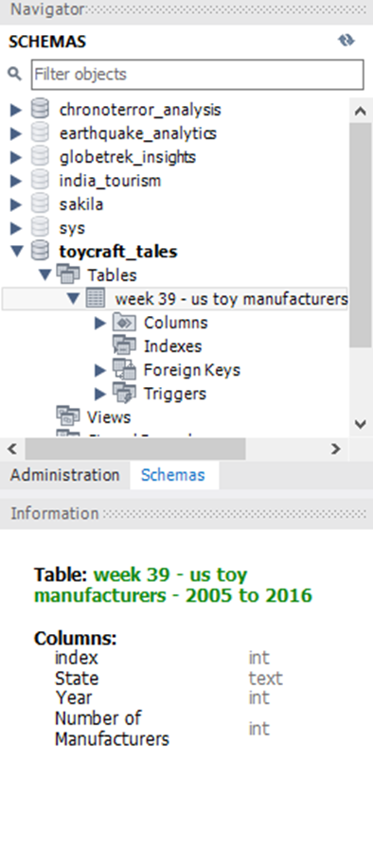

**Activity 5.2 : Utilization of Data Filters**

Data filters are used to narrow down the data being analyzed by including only the relevant information. Filters help in focusing on specific subsets of data, improving clarity, performance, and insights**.**

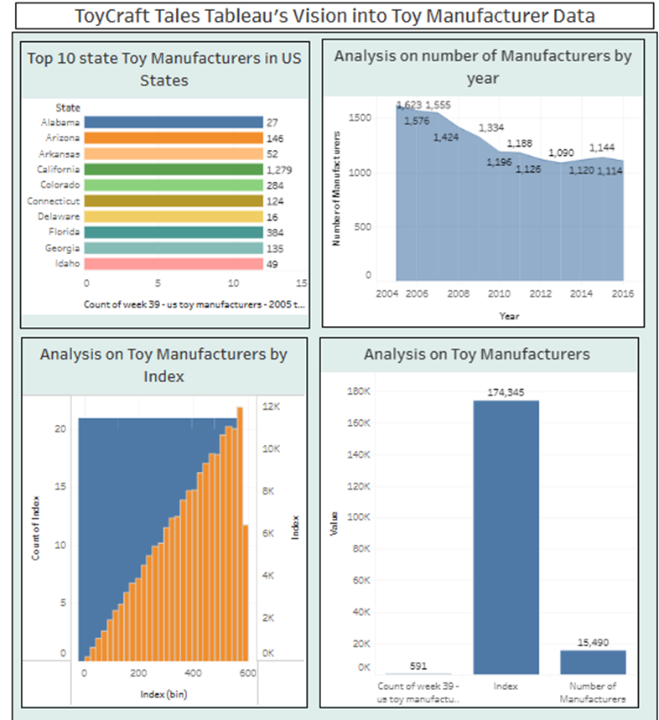

**Activity 5.3 : No Of Calculation Fields**

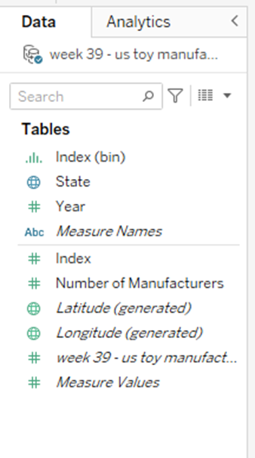

**Activity 5.4 : No Of visualizations / Graphs**

1. Analysis of the number of Manufacturers by Year
2. Analysis of Toy Manufacturer by Index
3. Analysis of toy Manufacturers in US state By Index
4. Analysis of Toy Manufacturers
5. Top 10 states toy manufacturer in US state

**MILESTONE 6 : WEB INTEGRATION**

**Activity 6.1 : DashBoard And Story Embed With UI with Flask**

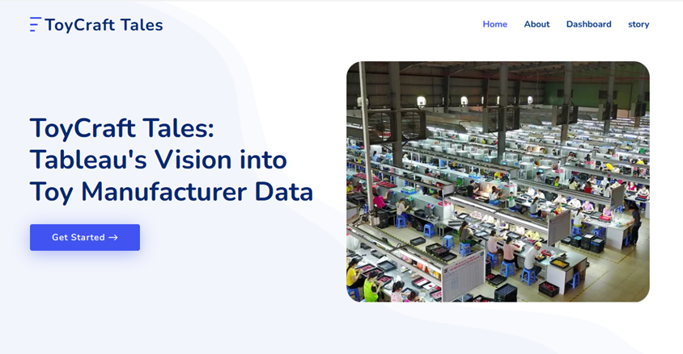

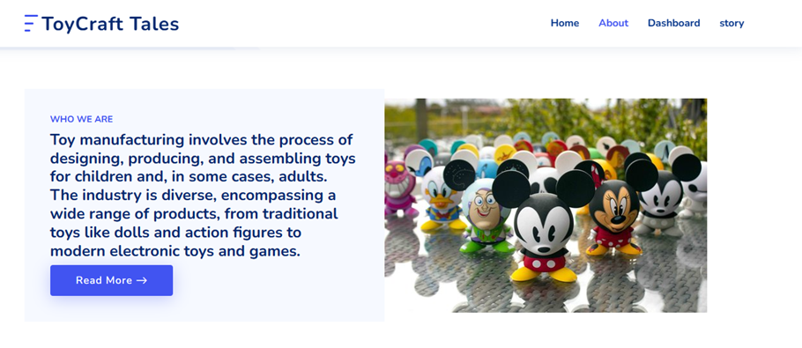

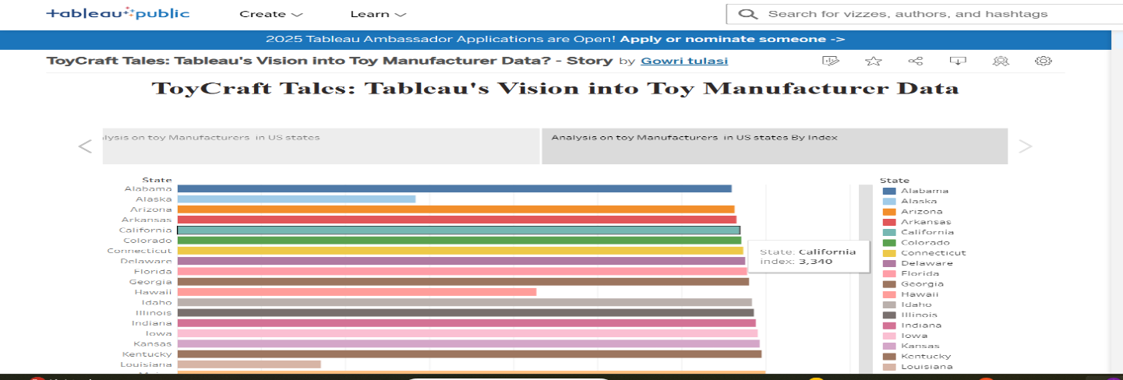

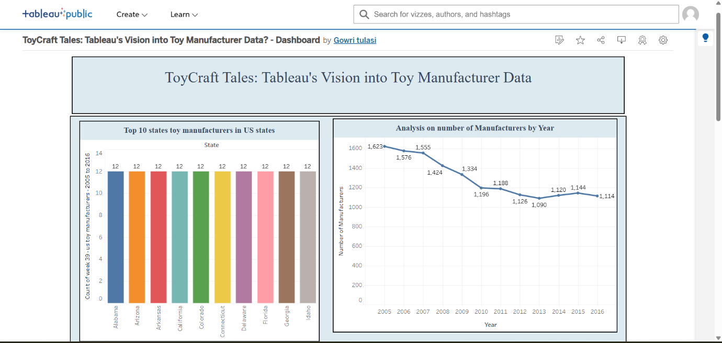

**MILESTONE 7:** **PROJECT DEMONSTRATION AND DOCUMENTATION**

https://photos.app.goo.gl/8qh24yV1VRVawUfK7